**Pushing Code to Bitbucket and**

**Azure Repository**

Krishnaraj S

ACE11698

* Create a workspace on your application name to push you application code.



* Give a meaningful name for your workspace.

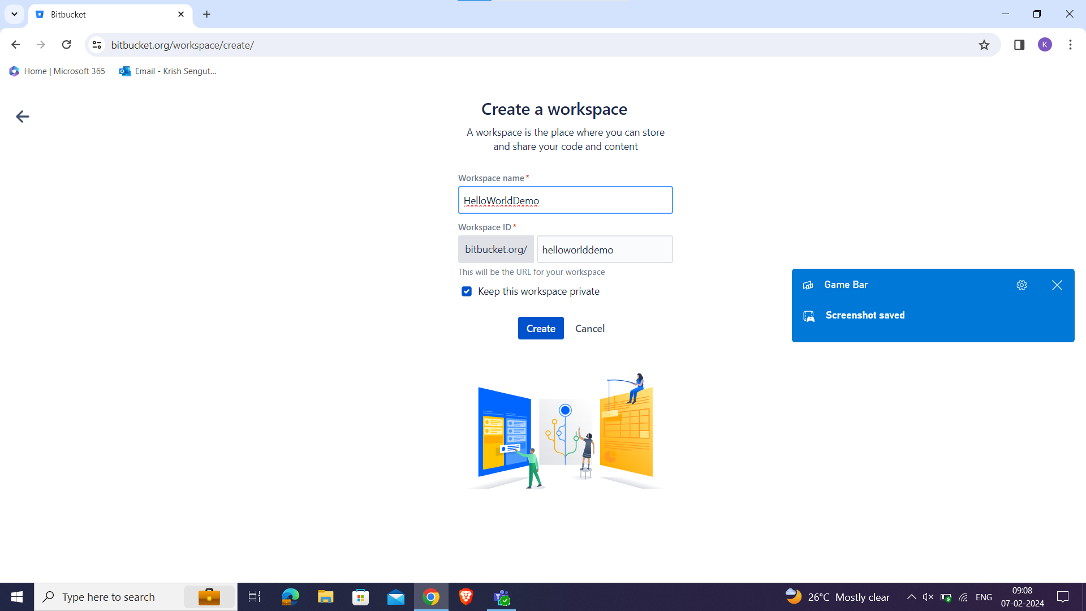

* Choose the Private of public for your repository and create your repository.

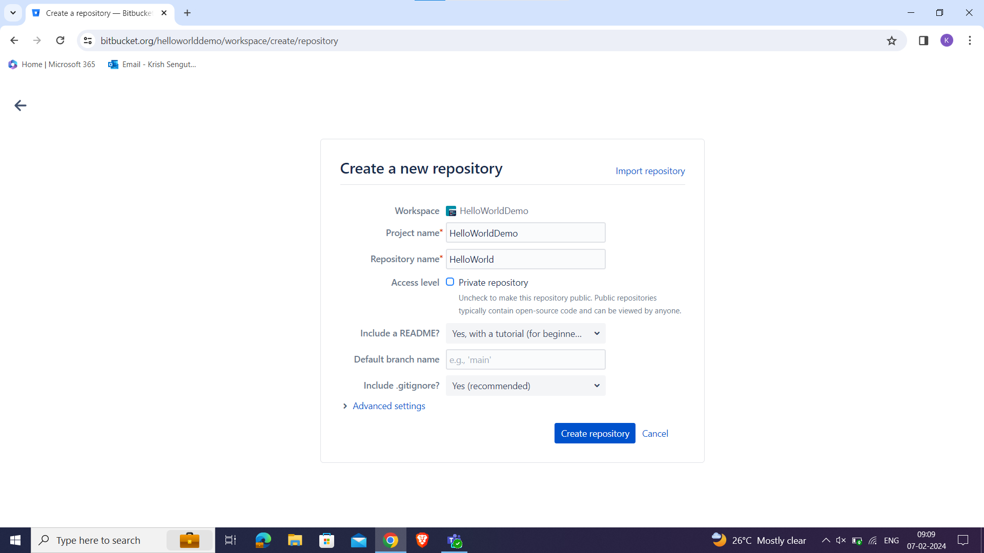

**Clone Bitbucket Repository:**

* Open a terminal or command prompt.
* Navigate to the directory where you want to clone the Bitbucket repository.
* Run the following command to clone the repository:
* git clone <Bitbucket_repository_URL>

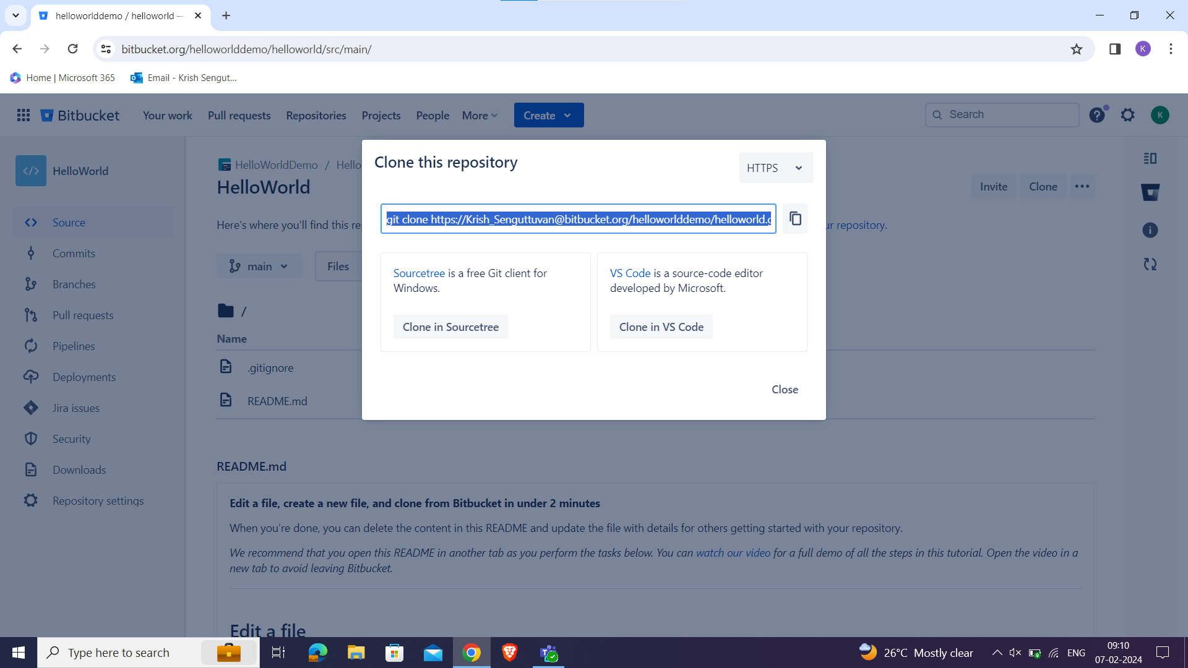

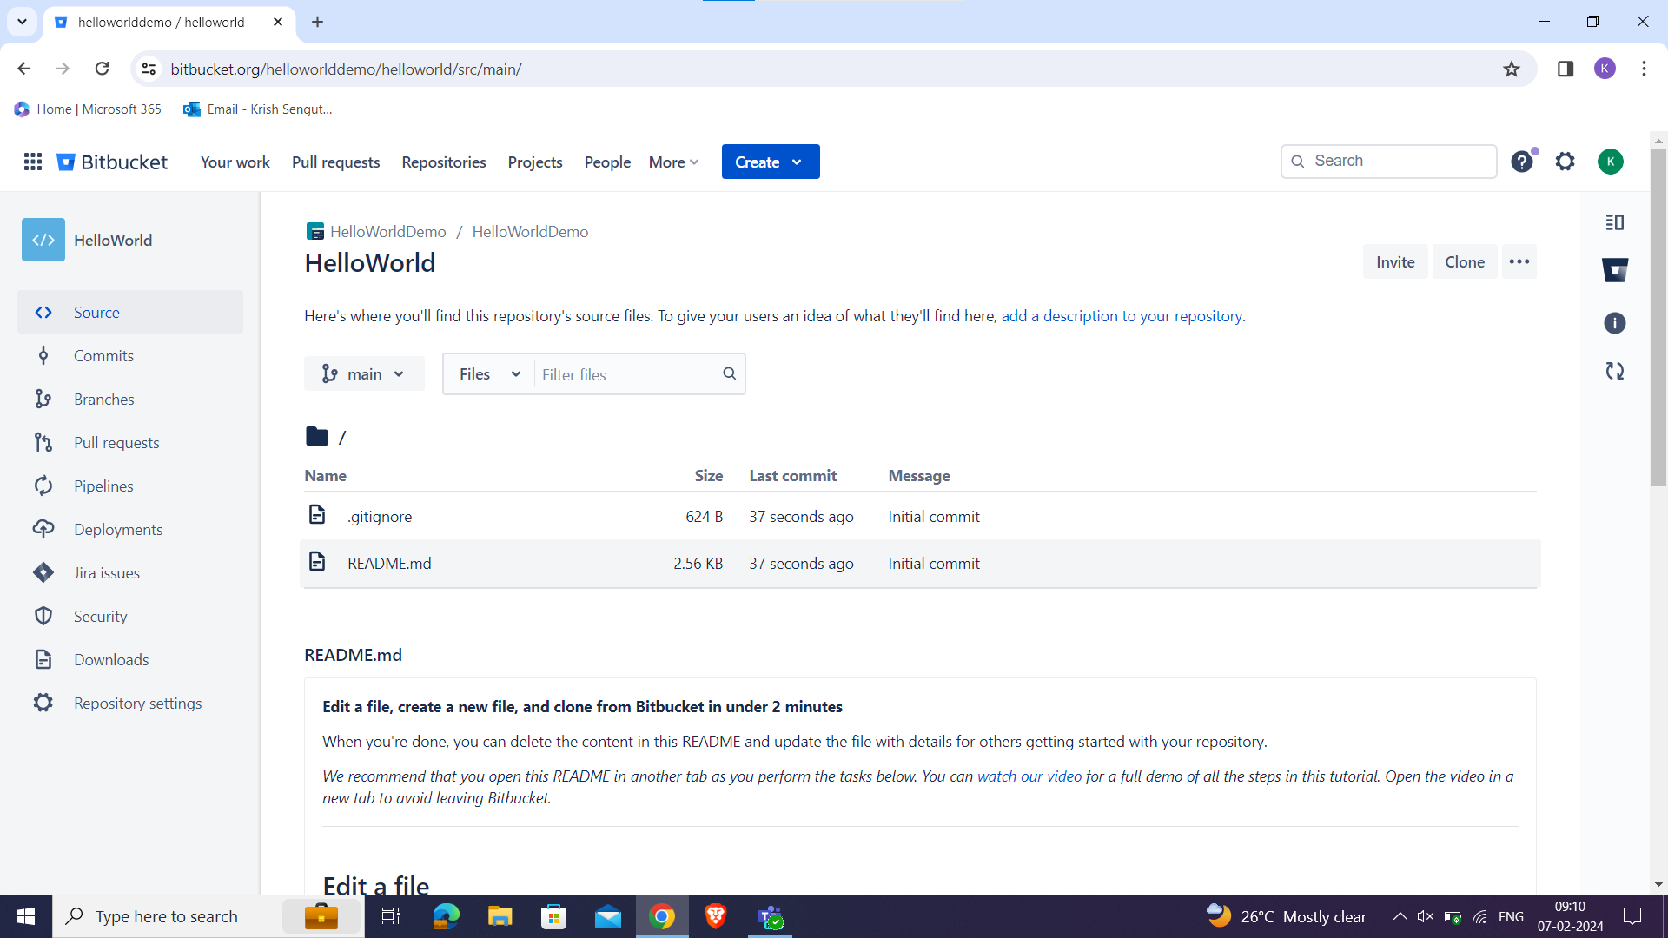

**Add and Commit Changes:**

* Navigate to the directory of the cloned repository.
* Add your files to the staging area:

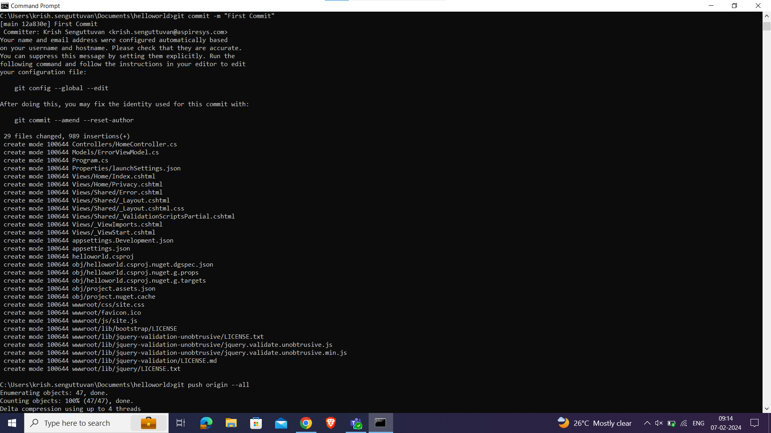

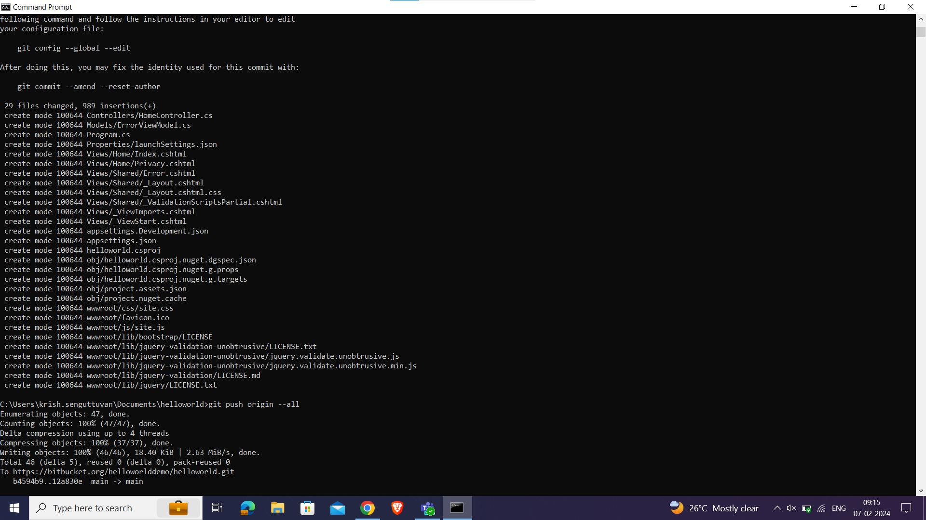

* All the program files are pushed to Bitbucket Repository

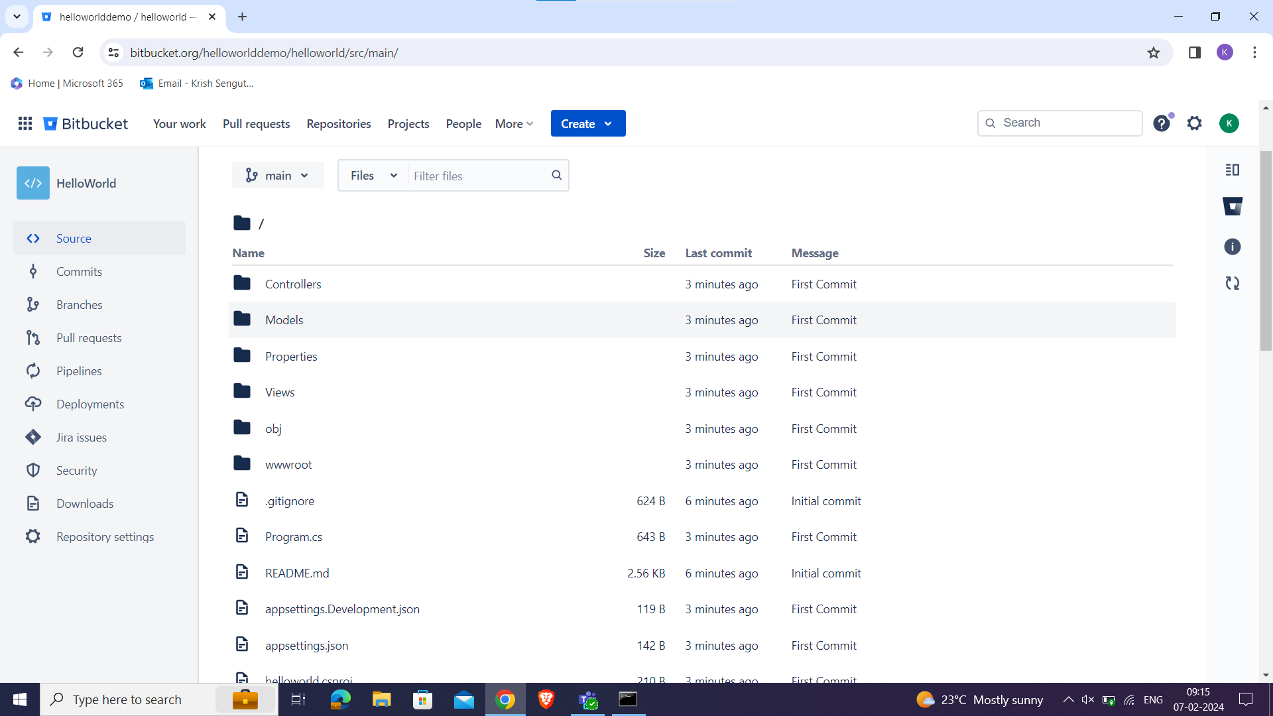

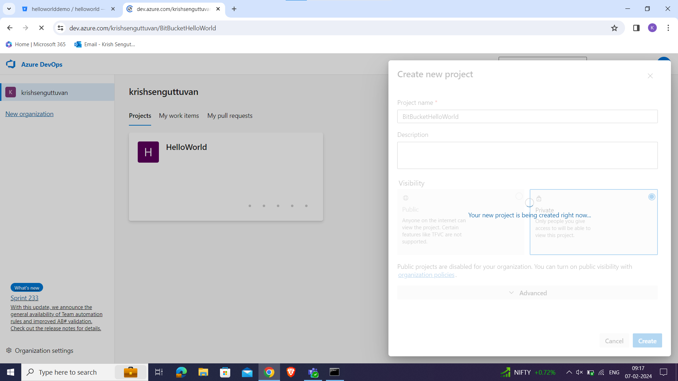

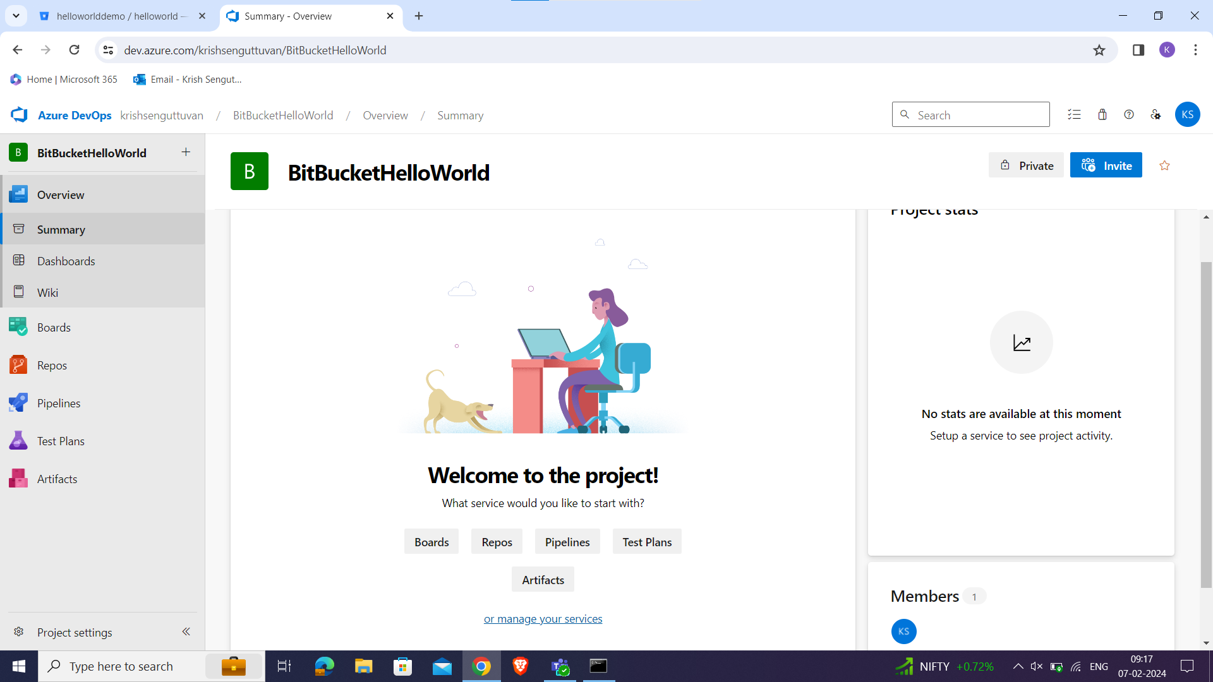

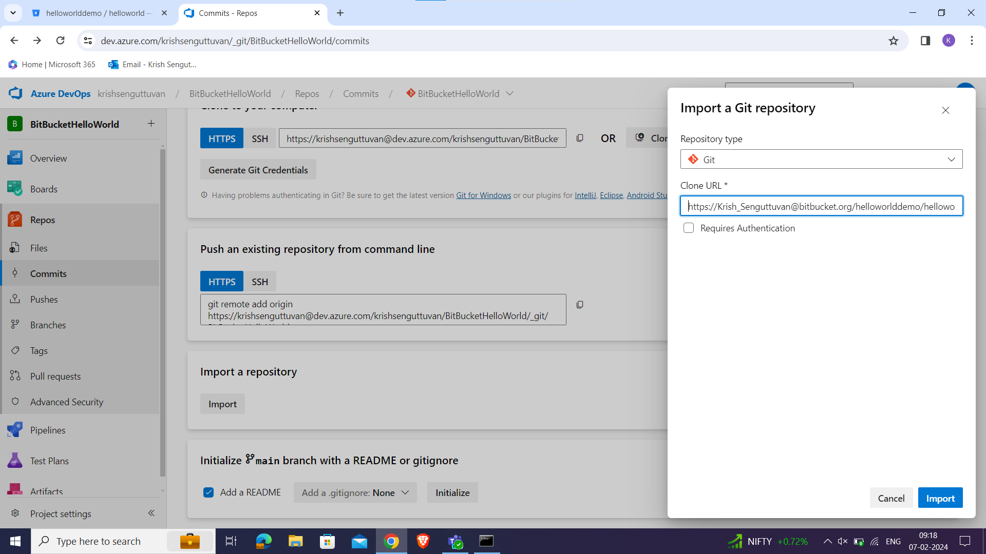

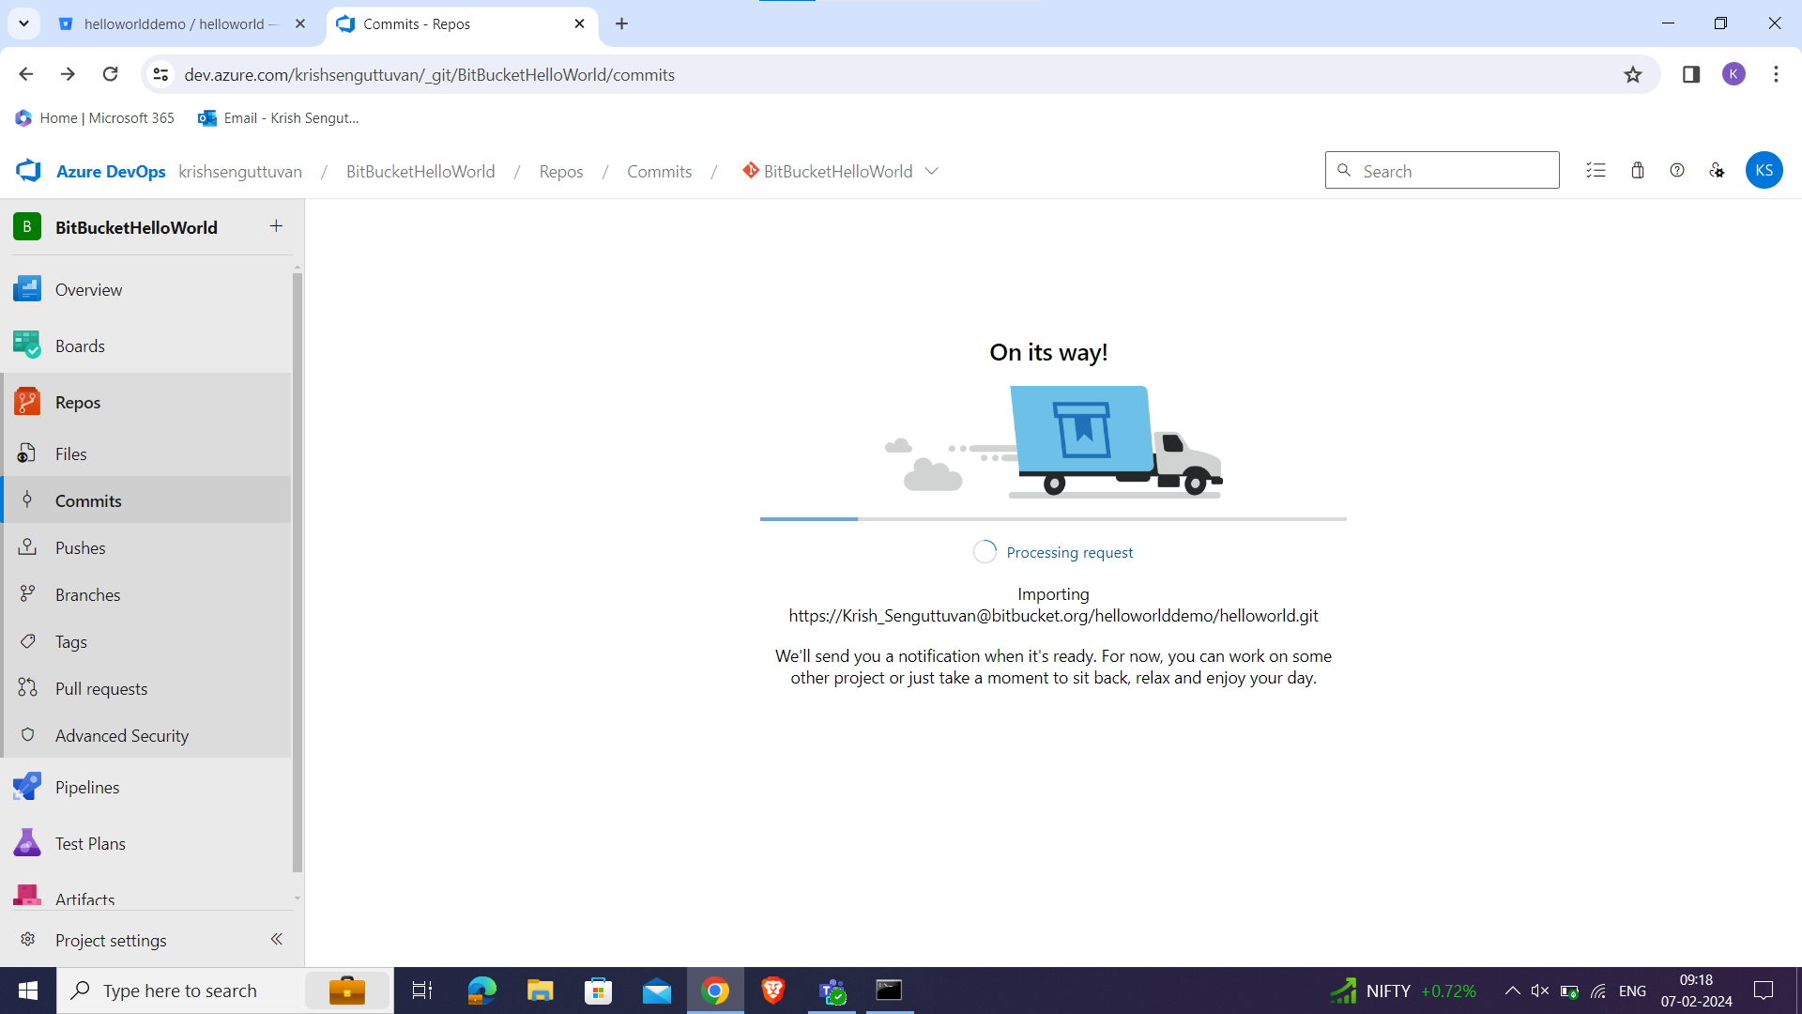

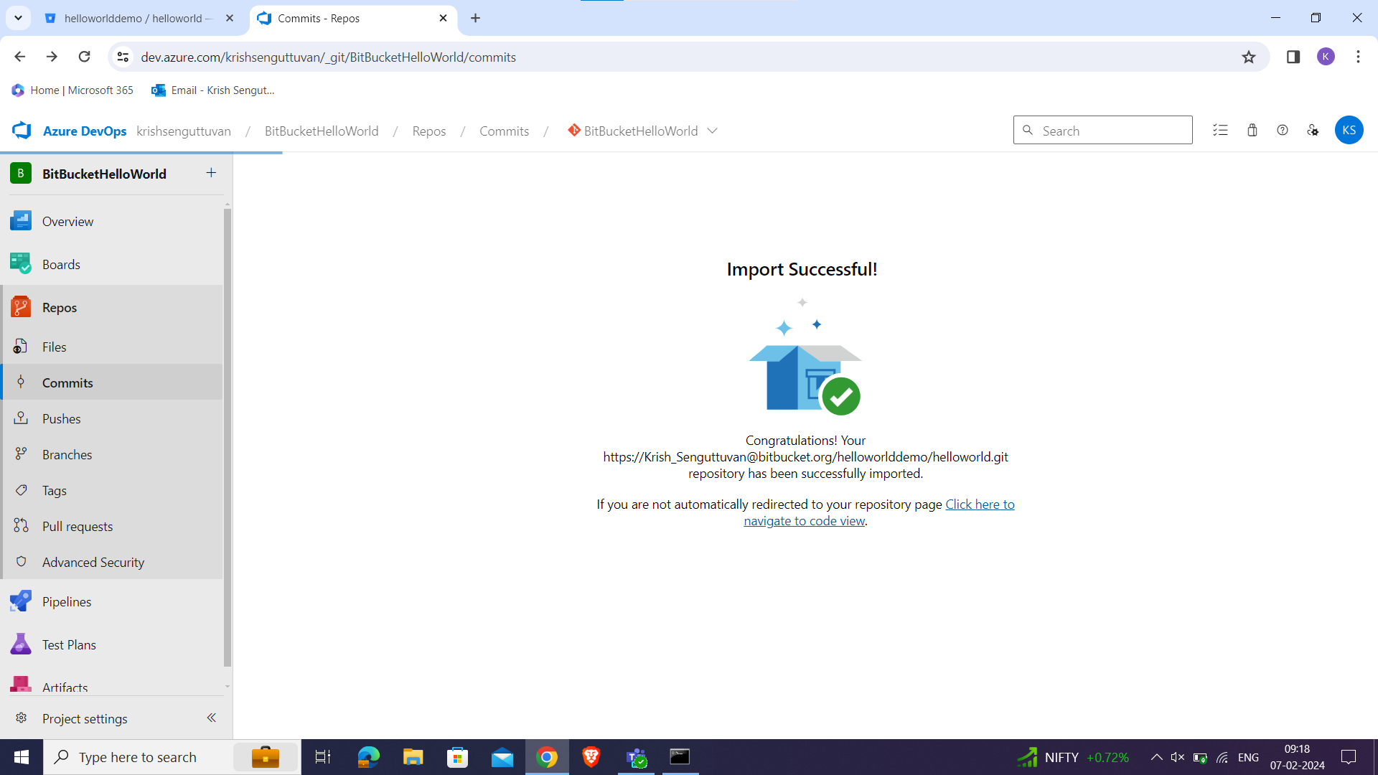

* Now, we have pushed all our programs to Azure repo from our Bitbucket repository.

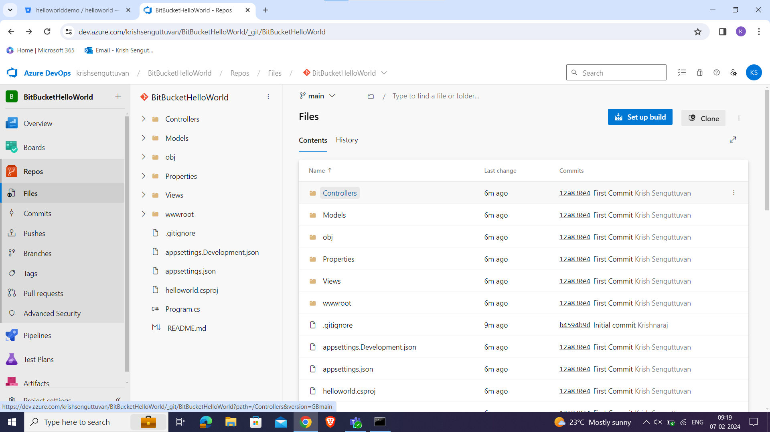

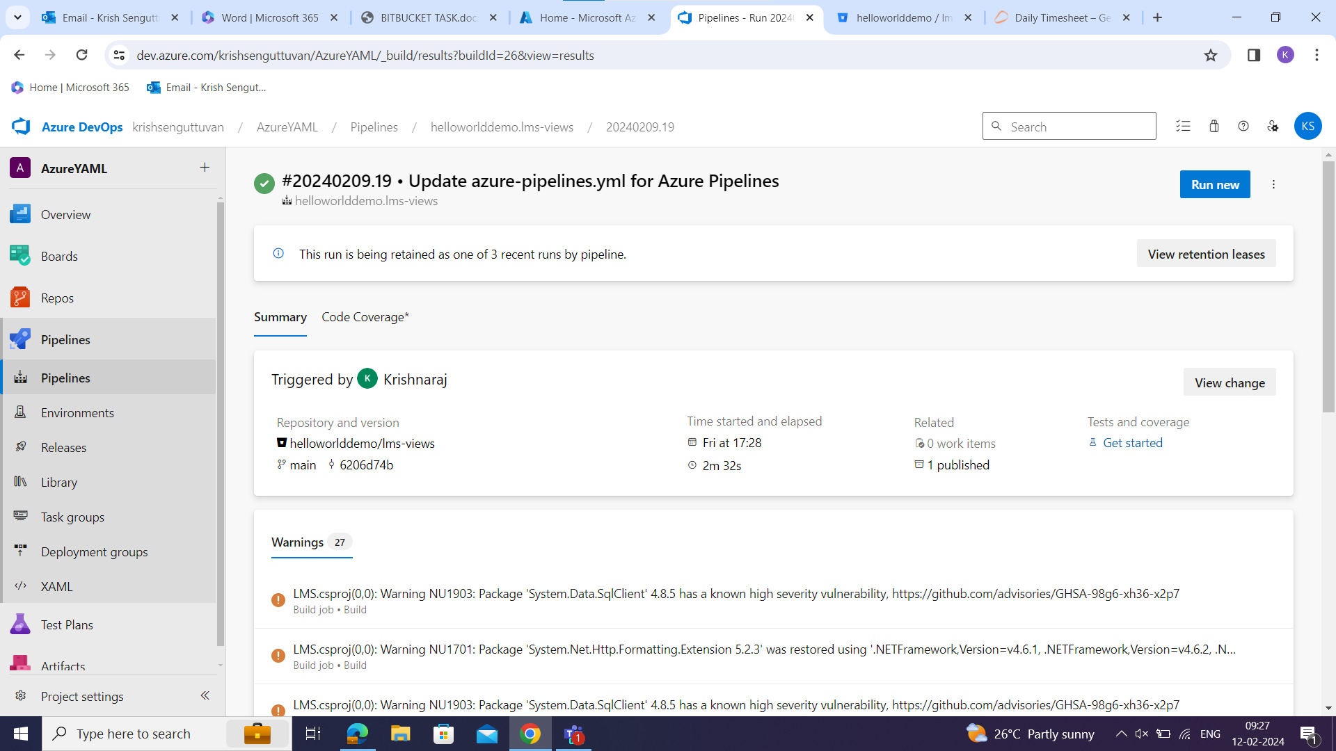

* Here we have coded a customised YAML to perform two jobs.
* First job is to BUILD, TEST and PUBLIS.
* Second job is to DEPLOY.
* If Job one fails, the second job will not execute.

